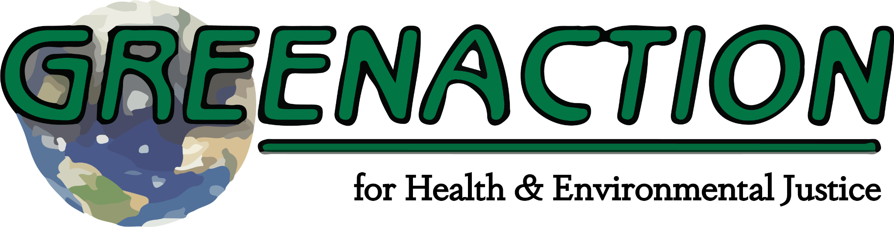

**PRESS ADVISORY: For Immediate Release**

**July 12, 2023**

**Contact:**

Miguel Alatorre/Greenaction for Health and Environmental Justice 559-816-3561/miguel@greenaction.org

Kamillah Ealom/Greenaction for Health and Environmental Justice

**COMMUNITIES IMPACTED BY POLLUTION TO DEMAND ENVIRONMENTAL JUSTICE FROM STATE DEPARTMENT OF TOXIC SUBSTANCES CONTROL AT MEETING OF DTSC’S SO-CALLED “BOARD OF ENVIRONMENTAL SAFETY”**

***Greenaction & residents from across the state to rally and speak out to demand action and accountability from DTSC, not more empty and broken promise***

**THURSDAY, JULY 13, 2023**

**12:45 PM RALLY IN FRONT OF EL CERRITO CITY HALL**

**1:30 PM COMMUNITY MEMBERS TO TESTIFY AT BES MEETING TO DEMAND JUSTICE**

*El Cerrito, California* - [Greenaction for Health and Environmental Justice](https://greenaction.org), a leading community action group, will join with residents and allies from across the state to speak out at a rally at 12:45 and then testify at 1:30 pm at the monthly Department of Toxic Substances Control’s Board of Environmental Safety meeting taking place Thursday, July 13th, at the El Cerrito City Council Chambers in El Cerrito, California. Top DTSC officials will be present and will be challenged to take action to protect communities, not polluters.

Community members from Bayview Hunters Point, West Oakland, Richmond, Kettleman City, Laytonville, Fresno, and other regions will be in attendance. Greenaction and residents from across the state will present environmental justice demands to the Board of Environmental Safety and the DTSC, urging them to address the pressing issues of pollution, contamination, and environmental injustice faced directly by their communities.

Residents and Greenaction will emphasize the need for equitable protection of public health, consideration of cumulative impacts in regulatory decisions, full cleanup of contaminated sites, compliance with civil rights obligations, closure of hazardous waste facilities operating on expired permits. Community members will share firsthand experiences and insights into the environmental challenges faced by marginalized communities, and advocate for sustainable and just approaches to hazardous waste cleanup and disposal.