Hunters Point Shipyard Superfund Site

Polluters Beware! Greenaction Starts 2019 Stronger Than Ever!
Thanks to our many supporters and activists, our staff and community-led Board of Directors, and two decades of successful campaigns and victories, Greenaction begins 2019 stronger than ever.

On December 15th, almost 100 supporters packed our office to help kick off our 22nd year of action, campaigns and victories for environmental justice. Together we also honored and celebrated long time Greenaction and Bayview Hunters Point environmental justice hero Marie Harrison. Despite irreparable lung damage that made it impossible for her to continue as a Greenaction community organizer, Marie joined our Board of Directors and stays active speaking out and advocating on the many pollution and gentrification issues facing Bayview Hunters Point.

Big Progress in Hunters Point Shipyard Superfund Site Fight for Better Cleanup and to Stop Gentrification Decades of tireless work by Greenaction and residents to expose the scandal at the Hunters Point Shipyard Superfund site in Bayview Hunters Point, San Francisco, is paying off. We forced the Navy, USEPA and the state to conduct more testing and cleanup due to federal contractor Tetra Tech’s fraud. We demand comprehensive sampling of the entire site, including parcels already transferred for upscale housing, and adjacent areas. We are challenging plans to leave radioactive and toxic waste buried at the San Francisco Bay waterfront, where rising sea levels threaten to inundate contamination. We are challenging and blocking plans by mega-developer Lennar/Five Points to build thousands of upscale homes that would gentrify the low income people of color neighborhood and expose residents to harmful contamination. Lennar/Five Points’ project is now in even bigger trouble as major banks have stopped offering mortgages for prospective home buyers at the new upscale development.
January 2019
Frontlines of Environmental Justice

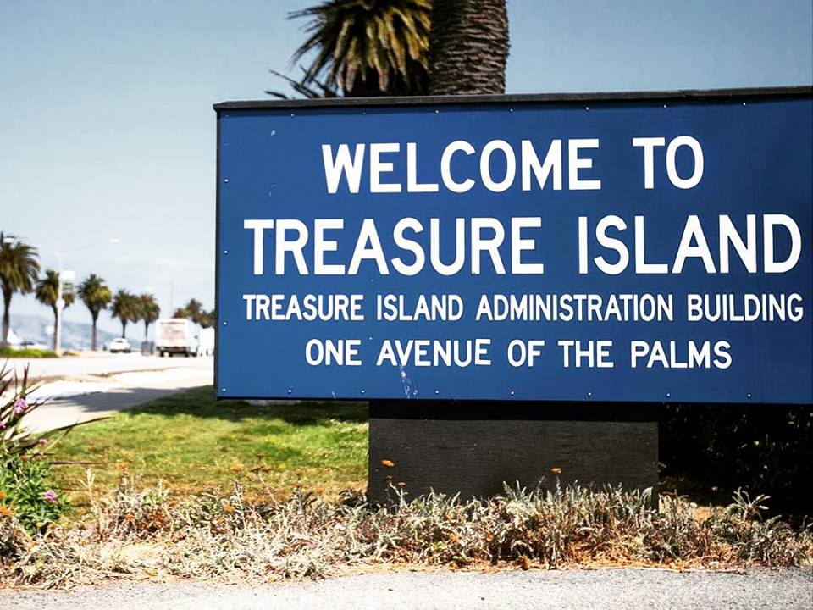
Greenaction Exposes Radioactive Threats and Coverup at Treasure Island, Government Forced to Respond
After years of claiming residents are safe living on contaminated Treasure Island in San Francisco and that the “cleanup” was going great, state and regional government officials got to see the truth during a “toxic tour” organized by Greenaction on October 17th. Many officials were shocked to see radioactive waste signs in peoples’s backyards, and took pictures of uncovered and unsecured piles of “dirt” in a radioactive “cleanup” area.

Faced with reality and held accountable by Greenaction, California EPA’s Department of Toxic Substances Control (DTSC) followed up and improved fencing at some of the contaminated sites, and either covered up or removed piles of radioactive soil.
Greenaction and residents are now stepping up our campaign for an improved cleanup, especially as rising sea levels threaten to inundate contaminated areas. Most importantly, we are supporting the demands of many residents that they be compensated and relocated away from this contaminated area.

SAVE THE DATE:
SUNDAY MAY 12, 2019
MOTHERS DAY WALKATHON FOR HEALTH & ENVIRONMENTAL JUSTICE
Golden Gate Park, San Francisco

Greenaction & El Pueblo of Kettleman City Launch New Projects for Health and Justice
With new energy from Kettleman City youth and young adults, Greenaction and El Pueblo are launching exciting new projects to protect the health of this overburdened community. With the long awaited replacement of the town’s toxic water supply just months away, youth are helping start a community garden project. Local farmers are donating equipment, fencing, and labor to plow the land. As the nearest grocery store is over 30 miles away, the garden will bring healthy and free food to residents.

We are also starting a major Community Air Monitoring project, funded with a grant from the California Air Resources Board. The project is educating residents about air quality through outreach and education, including an intensive youth leadership academy and training residents in using portable air monitors.

And the ongoing battles to close the giant hazardous waste landfills in Kettleman City and Buttonwillow continue, as the State allows the companies to keep operating on expired permits.

Greenaction & Tribal Members Fight to Relocate Residents from Toxic Contaminated Laytonville Rancheria
Honoring the last wishes of our friend and warrior for justice Louis Hoaglin, Chairman of the Wailaki Tribe, Greenaction and tribal members are keeping up the fight to get residents relocated from the contaminated Laytonville Rancheria in northern California. Louis passed away after a heroic fight against cancer. Dozens of tribal members have likely died from exposure to old leaking waste landfills that Mendocino County operated next to the reservation. Greenaction designed and helped tribal members conduct a community health survey that has documented cancer rates more than four times the state average. Stay tuned for action in 2019!

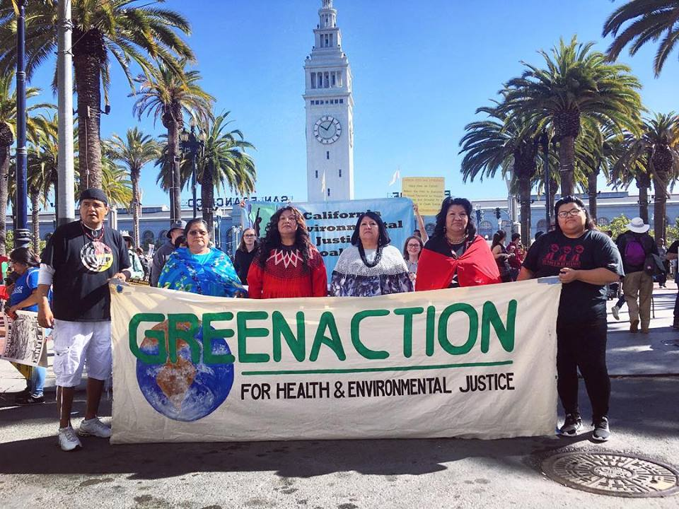

Greenaction Supports Winnemem Wintu Tribe’s Fight to Save the Salmon and Protect Sacred Sites from Shasta Dam In September, Greenaction joined the Winnemem Wintu Tribe on their two week, 300-mile, prayerful journey that follows the path of the salmon upstream along the Sacramento River watershed in northern California. The journey raised awareness about the importance of protecting the waters, defending sacred sites, restoring endangered salmon runs, and revitalizing indigenous lifeways in the face of climate change and ecological destruction. Now we are joining the Winnemem Wintu in their fight against the raising of the Shasta Dam, a project that would harm the environment and would destroy and flood important Indigenous sacred and culturally significant sites.
PLEASE SUPPORT GREENACTION IN 2019!
DONATE ONLINE OR BY MAIL!
Become a monthly or quarterly sustainer!
TAKE ACTION! GET INVOLVED!

Websites: greenaction.org & bvhp-ivan.org
E-mail: greenaction@greenaction.org
Facebook: @Greenaction4EJ
Twitter: @Greenaction_EJ
Instagram: @Greenaction_EJ

GREENACTION
315 Sutter Street, 2nd Floor San Francisco, CA 94108
(415) 447-3904

